Project: Woodson Park Academy & YMCA-ELC
Week Ending: October 4th, 2019

THIS WEEK:
- Foundations wall pours
- Storm line install continued
- Upper Level detention pond install
- Waterproofing of foundation wall

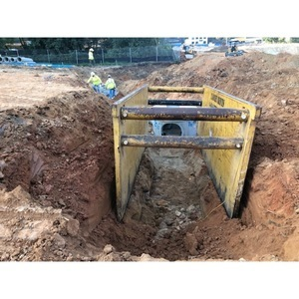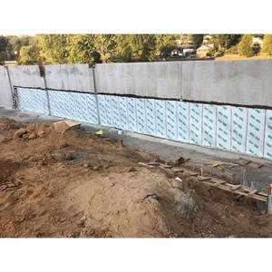

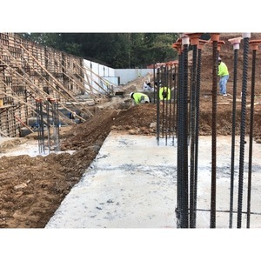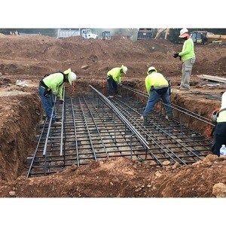

NEXT WEEK – October 7 thru October 11:
- Foundation wall
- Storm line install
- Cutting of NE parking lot grade

PAYMENT STATUS:
- Gmp#1 $3,703,488.00
  - Paid to date amount $646,892.85
- GMP#2 $28,686,295.00
  - Paid to date amount $0.00

SCHEDULED DATE OF SUBSTANTIAL COMPLETION
- WPA – September 28, 2020
- YMCA-ELC - September 16, 2020

PREPARED BY:
- Matt Dauber, Carroll Daniel Construction Co.

